I Implemented a webclient and webserver which supports GET and PUT method.
My programming IDE was eclipse: http://www.eclipse.org and my program consists of 2 .java files namely webserver.java and webclient.java
webClient: It is a very simple HTTP client, which takes the GET/PUT requests and send the request to the server and prints the response.
The Steps Followed is:
- Get the command-line parameters: host, port, GET/PUT and file name.
- Connect to the server via a connection-oriented socket.
- Submit a valid GET/PUT request.
- Read the server's response and display it.
WebServer: It is a very simple HTTP (web) server. It’s a multi threaded server. I implemented it with two classes, and it supports only the GET and PUT commands for HTML, text, GIF, and JPEG files.
- The Steps Followed are:
- Get the command-line parameters: port. If the port is not specified, set it to 80.
- Open a server socket on the specified port.
- Begin loop.
  - Wait for client connection, getting a reference to the client socket when the connection is received.
  - Create and start a new request thread, passing it the client socket.
- Get references to the socket input and output streams.
- Print the request information.
- If the command was "GET", send the response. If the file is found, it it is included as the content of the response. If it is not found, send "404 Not Found".
- If the command was “PUT”, it will save the file. If the received file from client is created for the first time, the server sends back a "Created 201" response to the client. If an existing file is modified, the server sends back a "OK 200" response to the client.
- End loop.
- Close the server socket and exit.

Running Conditions:
Kindly set the Run Configurations to input the command line arguments as shown in the screen shot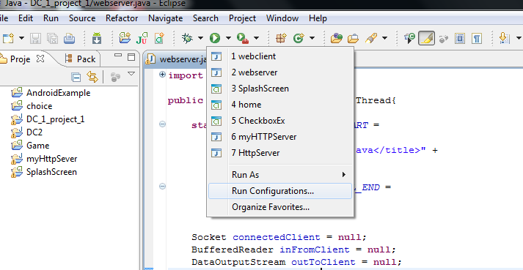
2. Set the command line arguments as shown in the screenshot below:
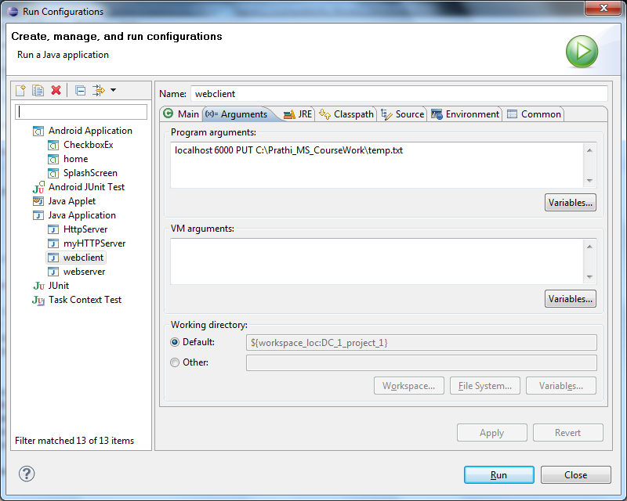
Output of the Program:
HTTP server Waiting for client on port 6000
We ensure the lab is webserver is running in the background and my server is configured to run on port 6000
- localhost 6000 PUT C:\RAJAT_MS_CourseWork\temp.txt
HTTP/1.0 200 OK
Server: Httpd
Date: Mon Oct 05 22:37:47 EDT 2015
Content-Type: text/html
Content-Length: 6
HTTP server Waiting for client on port 6000
The Client /127.0.0.1:51614 is connected
The HTTP request string is ....
PUT C:\Prathi_MS_CourseWork\temp.txt HTTP/1.0

File to be uploaded = temp.txt

- localhost 6000 GET index.html
HTTP/1.1 200 OK
Server: Java HTTPServerContent-Type: text/html
Content-Length: 40
Connection: close

This is my index and its is an html file

The Client /127.0.0.1:51617 is connected
The HTTP request string is ....
GET index.html HTTP/1.0

- www.google.com 80 GET index.html
HTTP/1.0 302 Found
Location: http://www.google.com/
Cache-Control: private
Content-Type: text/html; charset=UTF-8
X-Content-Type-Options: nosniff
Date: Wed, 05 Oct 2011 02:47:51 GMT
Server: sffe
Content-Length: 219
X-XSS-Protection: 1; mode=block

<HTML><HEAD><meta http-equiv="content-type" content="text/html;charset=utf-8">
<TITLE>302 Moved</TITLE></HEAD><BODY>
<H1>302 Moved</H1>
The document has moved
<A HREF="http://www.google.com/">here</A>.
</BODY></HTML>

- www.cnn.com 80 GET index.html
HTTP/1.1 400 Bad Request
Date: Mon, 05 Oct 2011 02:51:46 GMT
Server: Apache
Vary: Accept-Encoding
Content-Length: 287
Connection: close
Content-Type: text/html; charset=iso-8859-1

<!DOCTYPE HTML PUBLIC "-//IETF//DTD HTML 2.0//EN">
<html><head>
<title>400 Bad Request</title>
</head><body>
<h1>Bad Request</h1>
<p>Your browser sent a request that this server could not understand.<br />
</p>
<hr>
<address>Apache Server at www.cnn.com Port 80</address>
</body></html>

5.www.google.com 54678 GET index.html

HTTP/1.0 200 OK
Server: Httpd
Date: Mon, 05 Oct 2011 02:47:51 GMT
Content-Type: text/html
Content-Length: 1653

<!DOCTYPE HTML PUBLIC "-//W3C//DTD HTML 3.2//EN">
<html>
<head>
<meta http-equiv="Content-Type" content="text/html;CHARSET=iso-8859-1">
<meta name="description" content="BEA WebLogic Server">

<meta name="keywords" content="BEA WebLogic Server">

<title>Default BEA WebLogic Server Web Server Index Page</title>

</head>

<body bgcolor="#ffffff" LEFTMARGIN="10" RIGHTMARGIN="10"
link="#3366cc" vlink="#9999cc" alink="#0000cc">

<!-- CONTENT -->
<h3>BEA WebLogic Server&#153;</h3>

<h1>Web Server Index Page</h1>

<p>
<IMG height=11 src="images/redarrow.gif" width=11>

Visit the
<a href="http://www.bea.com" style="COLOR: #996600; TEXT-DECORATION: none">
<b>BEA Systems, Inc.</b></a>
web site to learn more about how BEA WebLogic Server
and the BEA WebLogic E-Business Platform provide you with the essential
infrastructure for building an integrated e-business.

<p>
<IMG alt="Built on BEA" border =0 src="images/built_bea_web.gif" >
Use the Built on BEA logo on all your WebLogic Server applications.
For more information on becoming a BEA Partner, see
<a href="http://www.beasys.com/partners/index.html" style="COLOR: #996600; TEXT-
DECORATION: none">
<b>Partner with the Market Leader</b>.</a>
</p>

<!-- FOOTER -->

<table cellspacing="0" cellpadding="0" border="0" width="100%" height="1">

<tr>
<td valign="middle" width="100%" bgcolor="#ff0000" height="1">
<p class="small">&nbsp;</p>
</td>
</tr>
</table>

<p> &copy; 2001, BEA Systems, Inc. All rights reserved.
</p>
</body>
</html>

